
1. Retrieve the names of all instructors who teach at least one course in the 'Computer Science' department.

SELECT DISTINCT i.name
FROM instructor i
JOIN teaches t ON i.ID = t.ID
JOIN course c ON t.course_id = c.course_id
WHERE c.dept_name = 'Computer Science';

2. List all students who have taken at least one course in 'Fall' and 'Spring' semesters in the same year


SELECT DISTINCT t1.ID, s.name
FROM takes t1
JOIN takes t2 ON t1.ID = t2.ID AND t1.year = t2.year
JOIN student s ON t1.ID = s.ID
WHERE t1.semester = 'Fall' AND t2.semester = 'Spring';

3. Find all classrooms that have a capacity of more than 100 but are not assigned to any section.
SELECT c.building, c.room_number, c.capacity
FROM classroom c
LEFT JOIN section s ON c.building = s.building AND c.room_number = s.room_number
WHERE c.capacity > 100 AND s.building IS NULL;

4 Display all courses along with their prerequisites, including courses that have no prerequisites.

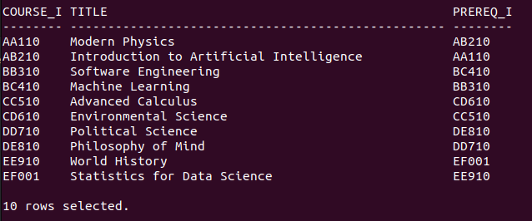
SELECT c.course_id, c.title, p.prereq_id
FROM course c
LEFT JOIN prereq p ON c.course_id = p.course_id
ORDER BY c.course_id;

5. Retrieve the list of instructors who have never taught a course.

SELECT i.ID, i.name
FROM instructor i
LEFT JOIN teaches t ON i.ID = t.ID
WHERE t.ID IS NULL;

6. Find the total budget allocated to all departments that have at least one instructor earning more than ₹100,00.

SELECT SUM(d.budget) AS total_budget
FROM department d
WHERE d.dept_name IN (
SELECT DISTINCT i.dept_name
FROM instructor i
WHERE i.salary > 100000
);13. Find all instructors who have taught at least one course that they did not belong to the department of.

7. Find the average salary of instructors grouped by department but only include departments with more than 5 instructors.

SELECT i.dept_name, AVG(i.salary) AS average_salary
FROM instructor i
GROUP BY i.dept_name
HAVING COUNT(i.ID) > 5;

8. Find the total number of students enrolled in each course for every semester, and sort by semester and number of students (descending).

SELECT t.course_id, t.semester, t.year, COUNT(t.ID) AS num_students
FROM takes t
GROUP BY t.course_id, t.semester, t.year
ORDER BY t.semester, num_students DESC;

9. Determine which department has the highest average course credit.

10. Find the top 3 courses with the most students enrolled across all semesters.
11. Find all students who have taken every course taught by the instructor 'John Doe'.

12. Retrieve the names of students who have the same name as their advisor.

SELECT s.name
FROM student s
JOIN advisor a ON s.ID = a.s_ID
JOIN instructor i ON a.i_ID = i.ID
WHERE s.name = i.name;

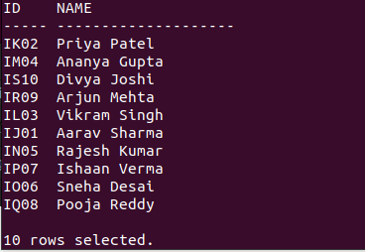
13. Find all instructors who have taught at least one course that they did not belong to the department of.

SELECT DISTINCT i.ID, i.name
FROM instructor i
JOIN teaches t ON i.ID = t.ID
JOIN course c ON t.course_id = c.course_id
WHERE i.dept_name != c.dept_name;

14. List all students who have taken a course in a classroom that has a capacity less than the number of students enrolled.

SELECT DISTINCT s.ID, s.name
FROM student s
JOIN takes t ON s.ID = t.ID
JOIN section sec ON t.course_id = sec.course_id AND t.sec_id = sec.sec_id AND t.semester = sec.semester AND t.year = sec.year
JOIN classroom c ON sec.building = c.building AND sec.room_number = c.room_number
WHERE c.capacity < (SELECT COUNT(*) FROM takes WHERE course_id = t.course_id AND sec_id = t.sec_id AND semester = t.semester AND year = t.year);

15. Find students who have taken every course offered by their department.


SELECT s.ID, s.name
FROM student s
WHERE NOT EXISTS (
SELECT c.course_id
FROM course c
WHERE c.dept_name = s.dept_name AND NOT EXISTS (
SELECT 1
FROM takes t
WHERE t.ID = s.ID AND t.course_id = c.course_id
)
);

16. Identify the department(s) with the largest number of distinct courses offered.

17. Find students who have taken a course but have not received a grade.

SELECT s.ID, s.name
FROM student s
JOIN takes t ON s.ID = t.ID
WHERE t.grade IS NULL OR t.grade = '';

18. Retrieve the details of instructors who have the exact same salary as another instructor.
SELECT i1.ID, i1.name, i1.dept_name, i1.salary
FROM instructor i1
JOIN instructor i2 ON i1.salary = i2.salary AND i1.ID != i2.ID;

19. Identify all courses that have prerequisites, but the prerequisite itself has no prerequisite.

SELECT c.course_id, c.title
FROM course c
JOIN prereq p ON c.course_id = p.course_id
LEFT JOIN prereq p2 ON p.prereq_id = p2.course_id
WHERE p2.course_id IS NULL;

20. Find all students who have taken courses in every semester (Fall, Winter, Spring, Summer) at least once.

SELECT s.ID
FROM student s
JOIN takes t ON s.ID = t.ID
GROUP BY s.ID
HAVING COUNT(DISTINCT t.semester) = 4;

21. Find all prerequisite chains for a given course (i.e., if A is a prerequisite for B, and B is a prerequisite for C, return A → B → C).

22. List all courses that have at least two levels of prerequisites (i.e., a prerequisite has another prerequisite).
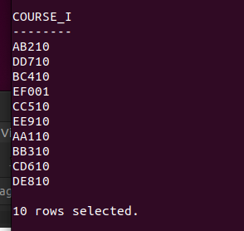
SELECT DISTINCT p1.course_id
FROM prereq p1
JOIN prereq p2 ON p1.prereq_id = p2.course_id;

23. Find the shortest prerequisite chain for any course that eventually leads to a specific course, say 'CS101'.
24. Identify students who have taken a course whose prerequisite they have never taken.
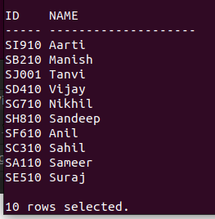
SELECT DISTINCT s.ID, s.name
FROM student s
JOIN takes t ON s.ID = t.ID
JOIN prereq p ON t.course_id = p.course_id
LEFT JOIN takes t2 ON s.ID = t2.ID AND t2.course_id = p.prereq_id
WHERE t2.course_id IS NULL;

25. Find all instructors who have taught a course that has another course as a prerequisite.
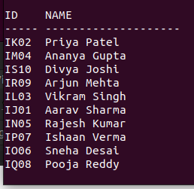
SELECT DISTINCT i.ID, i.name
FROM instructor i
JOIN teaches t ON i.ID = t.ID
JOIN prereq p ON t.course_id = p.course_id;

26. Find all students who have the same total credits as another student in a different department.
SELECT s1.ID, s1.name
FROM student s1
JOIN student s2 ON s1.tot_cred = s2.tot_cred AND s1.dept_name != s2.dept_name
WHERE s1.ID != s2.ID;

27. Identify instructors who have the highest salary in their department but still earn less than the highest salary in another department.
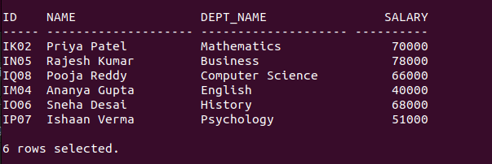
SELECT i1.ID, i1.name, i1.dept_name, i1.salary
FROM instructor i1
JOIN (
SELECT dept_name, MAX(salary) AS max_salary
FROM instructor
GROUP BY dept_name
) i2 ON i1.salary = i2.max_salary
WHERE i1.salary < (SELECT MAX(salary) FROM instructor WHERE dept_name != i1.dept_name);

28. Retrieve students who have taken more than one course but have failed at least half of them (assuming grade 'F' is failing).

29. List all departments where the highest-paid instructor earns more than the total department budget divided by the number of instructors.

SELECT d.dept_name
FROM department d
JOIN instructor i ON d.dept_name = i.dept_name
GROUP BY d.dept_name
HAVING MAX(i.salary) > (SELECT SUM(budget) / COUNT(*) FROM instructor WHERE dept_name = d.dept_name);

30. Find courses that have never been taught in the same semester for consecutive years.
SELECT DISTINCT c.course_id
FROM course c
JOIN section s1 ON c.course_id = s1.course_id
JOIN section s2 ON c.course_id = s2.course_id
WHERE s1.semester = s2.semester AND s1.year = s2.year – 1;

31. Rank instructors by salary within their department and return only the second-highest salary in each department.
WITH RankedSalaries AS (
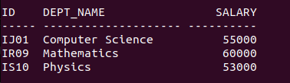
SELECT ID, dept_name, salary, RANK() OVER (PARTITION BY dept_name ORDER BY salary DESC) AS rank
FROM instructor
)
SELECT ID, dept_name, salary
FROM RankedSalaries
WHERE rank = 2;

32. Find students who have taken the most credits in a single semester.
33. Retrieve the top 5 students with the highest total credits, including ties.

WITH RankedStudents AS (
SELECT s.ID, s.name, s.tot_cred, RANK() OVER (ORDER BY s.tot_cred DESC) AS rank
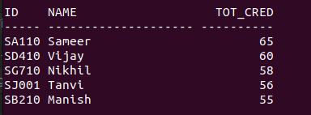
FROM student s
)
SELECT ID, name, tot_cred
FROM RankedStudents
WHERE rank <= 5;

